STA457_H1

Rafsaan Sanvir

2024-09-19

1a & c) Plotting ACF of dollar

acf(dollar, lag.max = 50)

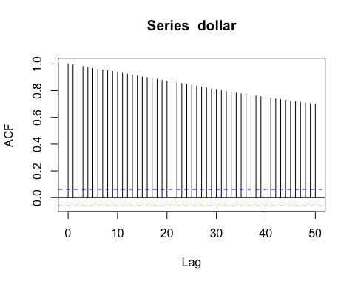 We can see that the acf is decaying to 0 very slowly. This implies that the trend is a long term memory series, as the correlations of xt and x(t+s) is high even after a time lag of 50 days. Which means the past is highly correlated with the future, and shocks to the system (sudden increase/decrease in exchange rates) can persist for a long time

Plotting spectral density function of dollar-

spec.pgram(dollar, demean = T, detrend = F)

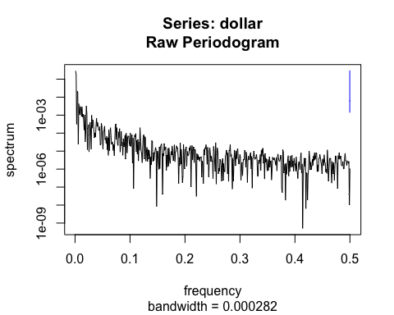

1b &b c) Plotting ACF for returns-

acf(returns)

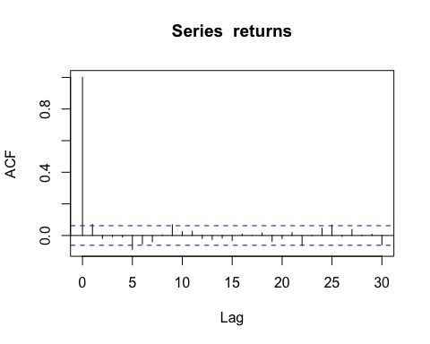

spec.pgram(returns, demean = T, detrend = F)

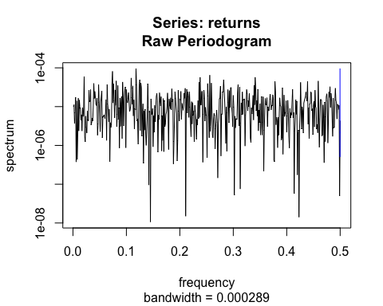

1c) ACF analysis For dollar variable, We can see that the acf is decaying to 0 very slowly. This implies that the trend is a long term memory series, as the correlations of xt and x(t+s) is high even after a time lag of 50 days. Which means the past is highly correlated with the future, and shocks to the system (sudden increase/decrease in exchange rates) can persist for a long time. For the first differences, the series decays to 0 extremely quickly, indicating a short term memory series where the past and present becomes uncorrelated within a very short time lag for the returns.

This finding is consistent with a random walk model, where first differences show no consistent autocorrelation and has a flat trend for frequencies between 0 and 0.5.

Periodogram analysis- For the first periodogram, covariances are the largest at lowest frequencies, indicating a long term trend in the exchange rate data. For the first differences, the covariance spikes are consistent throughout the graph, indicating that the first differences are more random, similar to white noise.

1d)

acf(abs(returns))

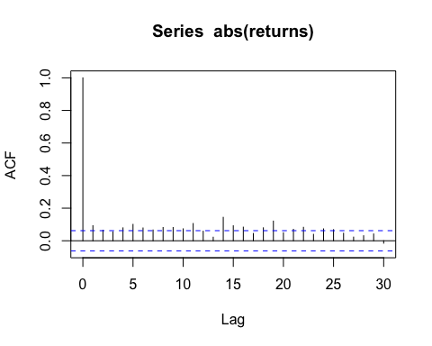

spec.pgram(abs(returns), demean = T, detrend = F)

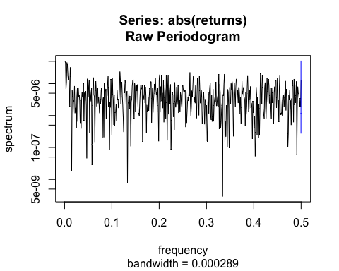

ACF- the acf of the absolute first differences or the magnitude of daily returns show stronger correlations than the original first differences. THis means that while returns are random/unpredictable, the magnitude (first diff of return) show autocorrelation

periodogram - The periodogram of absolute differneces looks similar to the original periodogram of first differences, once again indicating that the magnitude of first differences are random.

2a)

CO2 <- scan("Desktop/Current courses/Time series STA457/Assignment 1 /CO2.txt")  
CO2 = ts(CO2, start = c(1958, 3), end=c(2024, 7), frequency = 12)

spec.pgram(CO2, detrend = F, demean = T)

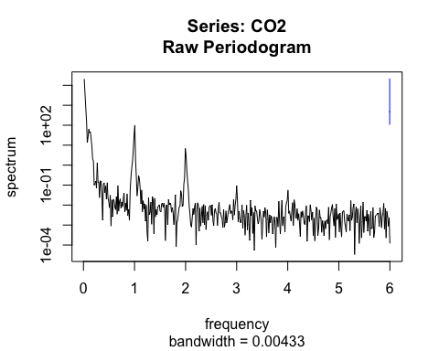 There are periodic peaks at 0, 1/1, 2/1, 3/1.. 6/1 cycles per year, and is called the harmonics of the basic frequency 1. it represents a possible seasonal component in the data, where there is a seasonal cycle repeating once every year, and smaller seasonal components that also repeats

2b)

CO2_trend <- scan("Desktop/Current courses/Time series STA457/Assignment 1 /CO2-trend.txt")  
CO2_trend = ts(CO2_trend, start = c(1958, 3), end = c(2024, 7), frequency = 12)

let’s subtract trend from original data

detrend = CO2 - CO2_trend  
par(mfrow = c(1, 2))  
CO2_spec = spec.pgram(detrend, demean = F, detrend = F)  
detrend_spec = spec.pgram(CO2, detrend = F, demean = T)

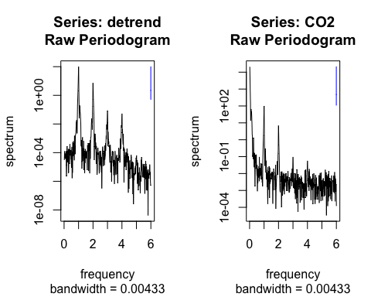

Here, we can see the spikes in data being more emhasized at the harmonics of the frequency 1. This reflects predictable spikes at certain frequencies of the C02 data.